The models I used had to receive a certain data format to train. The steps to get there, more or less, were these:

* I read all the files from a custom given PATH (in the .py, it needs to be hard-coded).
* After I receive all the information about the images from the .txt, I read all the images with matplotlib.pyplot.imread, returning an array of images (3 dimensions for each colour scheme).
* I “manually” normalised the images, I tried multiple methods: flattening, keeping the data between 0 and 1, etc, but nothing seemed to improve the accuracy in the end. I used a conventional way of normalising an image, left it in the last draft just for the sake of the time invested in them.
* Now that I have arrays with all the classes (labels) and the data itself, I just trained the models and compared the predicted classes with the actual classes to receive the metrics (including the accuracy).

For the Deep Hallucination Classification I ultimately used C-Support Vector Classification (SVC). I figured that the best parameter used for it is the “rbf” kernel. Some sort of preprocessing also helped, where StandardScaler from sklearn.preprocessing had the best improvements. The final prediction accuracy applied on the validation images was 0.55.

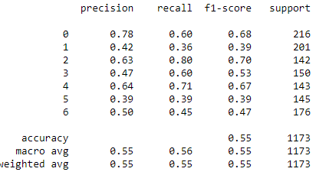

I also used more processing models, with less favourable results:

* Linear classifiers (SVM, logistic regression, etc.) with SGD training (SGDClassifier) had the worst results by far: only a predicted accuracy of 0.42. The best tuning I could muster in sklearn’s SGDClassifier was this collection: (random_state=42, max_iter=1000, tol=1e-3).

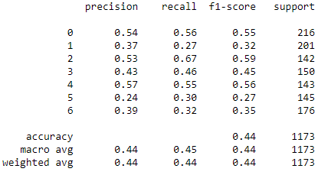

* LinearSVC managed to hit an accuracy of only 0.47 after 10000 iterations, after some tuning, as well (I added some preprocessing and I lowered the tolerance for stopping criteria).

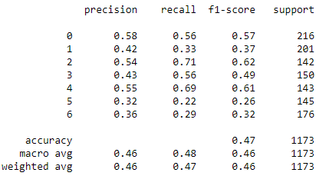

* By far, SVC was the best option, so I played a bit with the tuning options provided by sklearn, and I figured that:
  + SVC with the Normalizer preprocessing performed the worst, with only 0.53 accuracy.

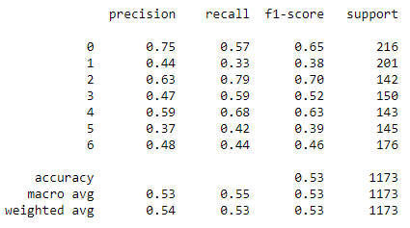

* + SVC, without any preprocessing, had an accuracy of 0.54.

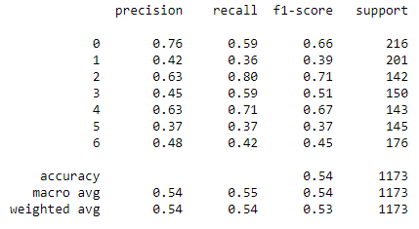

Also, the confusion matrix for the best model:

